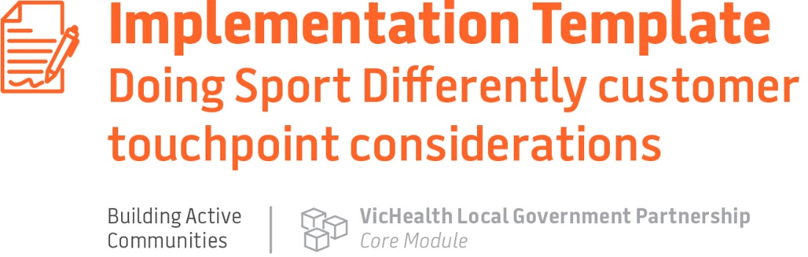

Doing Sport Differently customer touchpoint considerations

Touchpoint | Points to consider
Marketing | - Think about the images that you will use to promote your programs. The more closely these resonate, appeal and mirror young people’s experiences, the better. Make the imagery authentic and relatable so they can see themselves joining in.  - Words are important, too. Young people are engaged by statements like: ‘social’, ‘designed for your fitness level’, ‘no experience required’, ‘no judgement’.  - Reach out to young people who have exited the sport. They may be open to a social sport program, particularly if they left because it became too competitive or too time consuming.  - Strategies that are the most successful include:  - word of mouth or bring-a-friend sessions  - paid or shared social media posts, where friends are tagged  - flyers in local cafes  - partnerships with organisations that already engage with young people, e.g. schools, universities, Scouts, workplaces
Registration | - If a young person takes that important first step and wants to register for a program it must be as simple, quick and easy as possible.  - Offer a ‘come and try’ session for people who are interested but not yet ready to commit to a full program.  - Provide all the information they need at registration, including clear instructions on what to wear, where to go, what time to turn up, and who will be there to meet them.  - Allay any fears or anxieties by detailing what they will experience in their first session. For example, the first session will include some time getting to know each other and learning a few skills.
The welcome | - The welcome really starts with the marketing and registration.  - Even the most confident people feel nervous about doing something new for the first time.  - Strategies that can be used to welcome young people include:  - Making sure there is a clear place marker at the session location so participants can easily find the session and don’t have to roam about feeling lost.  - Providing a friendly introduction and greeting from the facilitator as soon as a young person arrives. The greeting needs to be authentic and friendly, ensuring the new participant feels welcome like it’s a friendly place to be.  - Showing them around, introducing them to other participants and pointing out key things (e.g. toilets).
Correcting mistakes | - Recognise that many young people will be learning new skills, which will inevitably lead to mistakes. Some ‘technique focused’ coaches may try to fix and highlight participant mistakes but in social programs, mistakes need to be managed quite differently.  - Ensure that the facilitator has soft skills like empathy, understanding and a supportive approach.  - Set the tone at the start, by saying things like: “It’s ok if you make a mistake, don’t worry about it, just keep going – there is no judgement here”.  - If a mistake is handled badly, any positive goodwill that has been built can be lost in an instant and the risk is they won’t come back.
The invitation to return | - The perception might be that once a young person has attended the first session they will automatically come back again. This might not be the case.  - The invitation back is sometimes a forgotten step but one that can make a huge difference. The facilitator again has a key role to play here.  - At the end of the first session they should take the time to thank the young person for attending, reinforce that it was great to have them there and offer a direct and genuine invitation to come back next session. This creates a sense of personal connection, builds rapport and shows the participant that their presence was valued and they are now part of the group.  - A follow-up phone call/text/message after the session can be useful to check in and hear any feedback.

Engage young people throughout the design process to reduce barriers and fulfil motivations (Principle 1)

Talking to young people and hearing their opinions and ideas is one of the most important things you can do. In practice, this can involve surveys, focus groups, advisory committees and partnerships with organisations that can help connect you with young people. Some examples:
- Survey young people within your community to understand:
    - how they feel about sport
    - what sport and recreation activities they have participated in
    - what has stopped them from participating
    - what sport and recreation activities they would like to see in their community
    - most importantly, what they don’t want.

- Help clubs, leagues and associations to work with young people and engage youth voices within their club and also outside their club.
- Your council may already have a Youth Advisory Council or similar in place. Consider how you can use this group to be local champions and ambassadors to talk to young people from your chosen population group. If your council is in regional Victoria, you may be able to tap into the Youth Advisory Committee run by Regional Sport Victoria.
- Young people should not just be stakeholders in the design processes at the club or with other providers – where possible, they should lead this work.

Think of young people as customers and consider their total experience (Principle 2)

The second principle is about seeing young people as customers and considering their total experience. It’s about providing positive experiences from the first time they see your program marketing through to the end of their involvement with the activity.

This principle includes the 5 key customer experience touchpoints. These are important as they are the moments when a young person will decide:
- if they want to get involved at all
- how they feel about the program
- if they will come back.

Participation should cater to different levels of skill, ability and fitness (Principle 3)

This principle is about ensuring the sport session for young people caters for the motivations behind why they decide to participate; and the varied levels of skills, ability and fitness.

VicHealth has identified the top 5 motivations for participation that are critical to factor into the design and delivery of your social sport program:

- having fun
- spending time with friends
- improving fitness levels
- learning new skills
- meeting new people.

Also be aware that young people come to a program from different backgrounds and with varied abilities, confidence and skills. Some may have prior sport experience and some may have none. Think about young people who are completely new to an activity and are being asked to use sports equipment that they have never used. This can be a barrier to participation and stressful for some.

Social sport works best when young people can have fun and learn new skills through activities that can be adapted and modified for all participants in the group, relative to their starting position. This allows participants to increase their level of confidence and ability over time.

Some examples of how to adapt:
- modified cricket using a softer ball and lighter bat
- golf program that can be done in pairs – helps learning but also enables the young person to do the activity with a friend, which can alleviate stress and create more fun.

The deliverer is the most important person to participants’ experience and retention (Principle 4)

This principle is about having the right facilitator, coach or instructor who understands and connects with the young people in the group – this is the most important element of your program to get right.

Creating a positive social environment is the most important aspect to engaging and retaining a young person in a social sport program. A great deliverer will make it much more likely that a social sport program will provide the positive experience that people are seeking.

While deliverers could be traditional coaches, the primary qualities and skills needed by deliverers for social sport may be different to those required for traditional sport. Look outside existing sport structures and networks to grow a pool with the right skills for a more social offering.

The best deliverer for social sport does not need to be an expert in technique, rules or drills. They need:

- certain social skills, behaviours and personality traits
- the ability to establish and maintain a social and encouraging feel to the program
- the ability to be flexible and adaptable; and build rapport among the group.

In your design stage think about whether the deliverer could be a young person. They may be more likely to resonate with other young people and it can also be a good way for a young person to develop new skills and experiences. The right person can be trained up on the program content. The key is finding the right person.

Young people need a clear pathway for retention or transition as their skill, fitness or interest changes (Principle 5)

This principle is about ensuring young people have options to continue participating if they want to – whether that is in the social sport program itself or something else. This requires an acknowledgement that some participants may want to:
- do the program once
- continue participating in the program several times
- go onto other options.

It is important to consider ‘What’s next?’ for young people who join in and participate.

- While some people who come into social sport programs may continue to club membership or more traditional offerings, this cannot be assumed for everyone. In some cases, pushing a membership or a long-term commitment could have the opposite effect, particularly for young people looking for options with less commitment.
- When there are multiple options available to participants, they can be informed and empowered to consider their options and transition to other offering if they choose.
- Successful transitions are often dependent on the quality and knowledge of the facilitator and how well they encourage continuation and link to new opportunities.

An example of this is the Coasting for Teens program where young people can join in a social fun paddleboard session to learn basic skills. At the end of the session the options are discussed for what happens next. For this program, they can join in another session to improve their skills and get more experience (either at the same location or a different one). If they feel confident enough, they can hire a stand up paddleboard and go out on the water with family or friends.

Best-practice project management and delivery will enable scale and sustainability (Principle 6)

Principle 6 places value and importance on good project management and delivery. This is the work done – often behind the scenes – to help the program succeed and grow and be sustainable.

The longer-term sustainability of the program is important to consider at this point of the planning stage. Councils should demonstrate a real and meaningful commitment to partners and young people that this work is important, long-term and in no way tokenistic. This will help build trust and is a good step to developing authentic partnerships with the community. Some points to consider at this stage:

- How will the activity continue into the future beyond a one-off event or program, e.g. will you run a program every term or for the whole sport season?
- How can the activity be embedded into existing club or provider core business over the long term? For instance, council may run a targeted basketball program initially at the local council-owned basketball court and have a local club coach run the session. Over time the plan will be to transition the program so that the local club and coach incorporate it as part of their regular club activity.
- How can you upskill and build the capacity of club coaches or providers to run the activity in a way that is inclusive? Once key members of a club or an activity provider is trained, that knowledge, skill and expertise remains with them and they are then able to run an inclusive program again and again.
- How can young people from the community take a key role in delivering the activity? For instance fund young people from the local community to complete coaching courses so they can run the activity for their community.
- What pathway is available for individuals who wish to continue to participate? Consider if that might be connecting them to a club or ongoing provider or even connecting them into other types of sport or physical activity opportunities.
- What other grants or funding might be available to support the activity or the individual to continue beyond the initial program? Look at local grants, state and federal government grants and philanthropic organisations.

Always keep in mind the important role young people can play in becoming leaders within community sport. Think beyond participation on the field to roles in coaching, on committees and in other leadership roles within sport.

Underpin this work with a process of continuous quality improvement, to test and refine elements of the program based on feedback from participants, providers and partners.

